1. Please install “fiddler” using below URL:

<https://www.telerik.com/download/fiddler>

1. Once it is install, Please type “fiddler” in command window and click on “OK”, fiddler tool will get open:

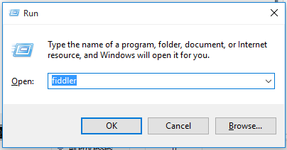

1. Disable “Capture Traffic” by pressing “F12” or go to File menu and un-select “Capture Traffic”.
2. Remove initially captured traffic, by selecting “Remove -> All Session” or CTRL+X.

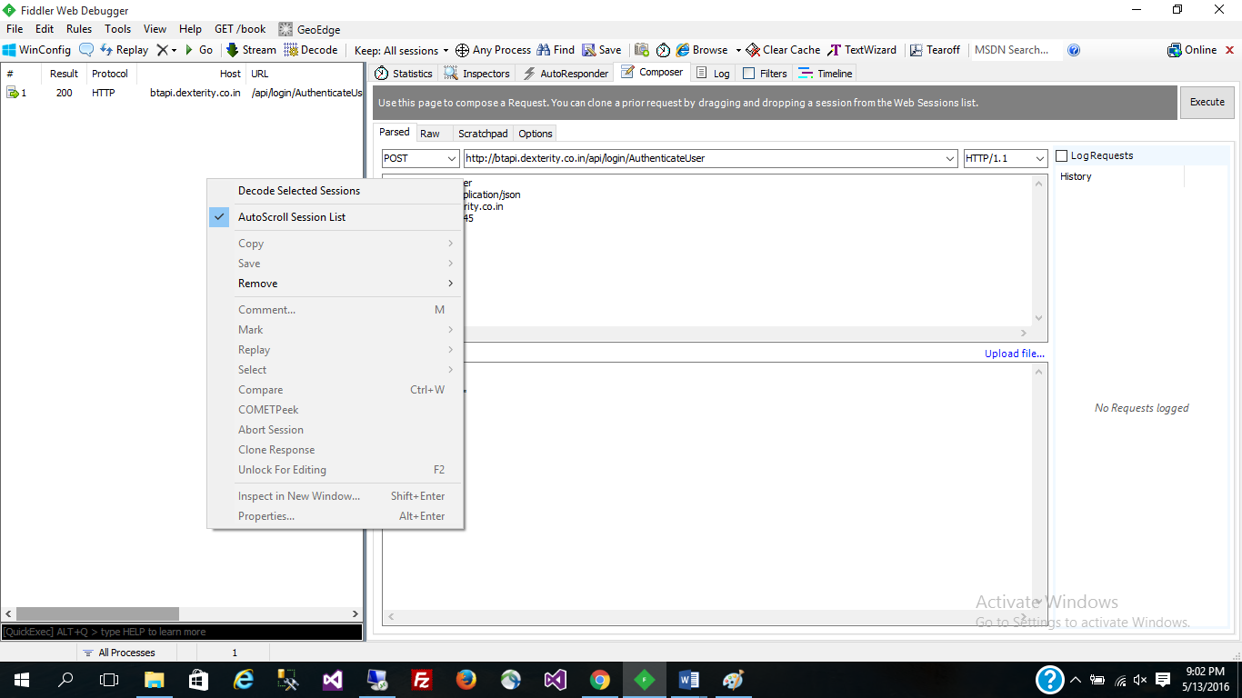

1. Please select “Composer” tab from left panel (refer screen shot)

* Select “Parsed” tab, then select “POST” option from dropdown and type URL <http://btapi.dexterity.co.in/api/login/AuthenticateUser> in address bar.
* Paste below content in first text area
  + User-Agent: Fiddler
  + Content-type: application/json
  + Host: btapi.dexterity.co.in
  + Content-Length: 45
* Paste below content in second text area
  + {
  + "LoginName": "6",
  + "Password": "Skis"
  + }
* Click on Execute button. In left panel you will see the status of action.

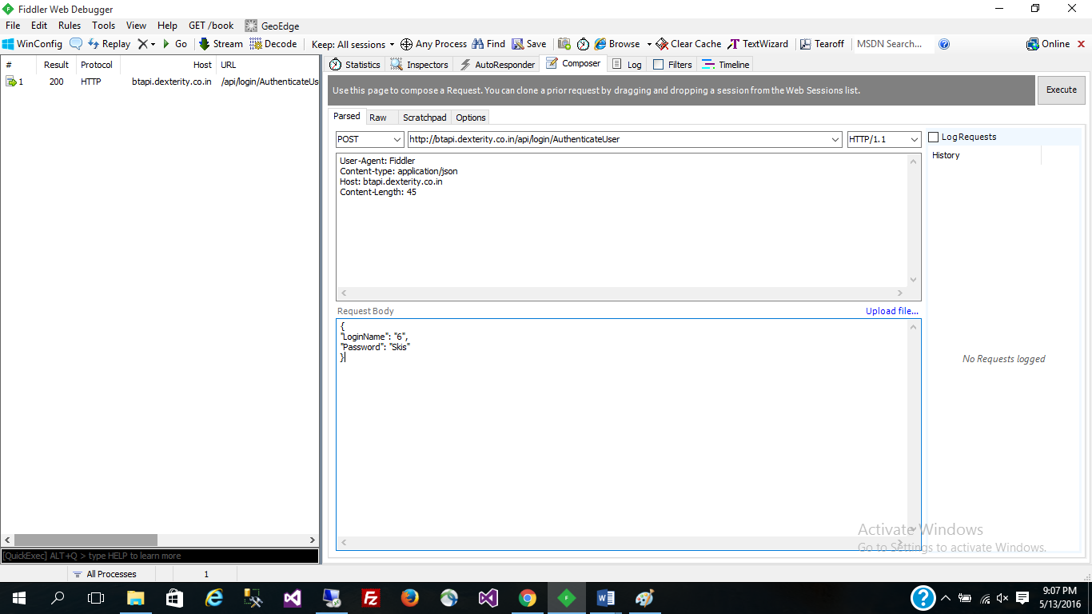

* Double click on result and you will be landed on below page, in which you can see the output of API:

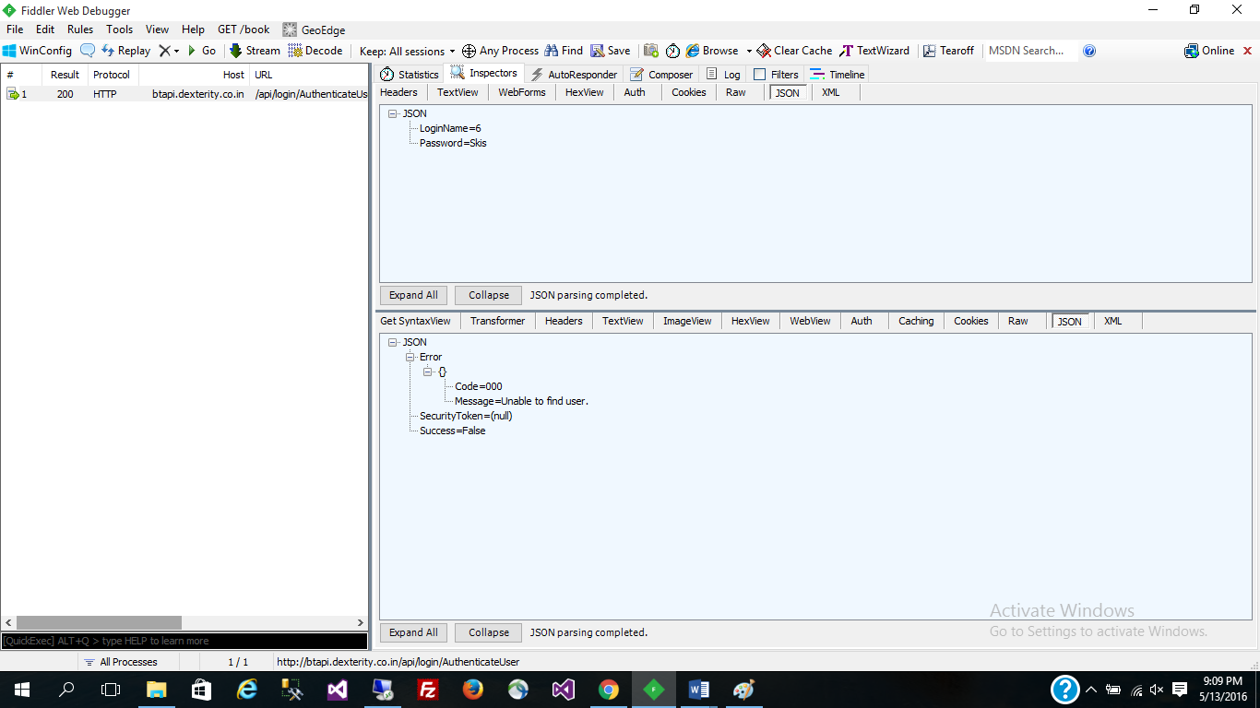

1. Please select “Composer” tab from left panel (refer screen shot) to

* Select “Parsed” tab, then select “POST” option from dropdown and type URL <http://btapi.dexterity.co.in/api/Upload/UploadFile> in address bar.
* Paste below content in first text area
  + User-Agent: Fiddler
  + Content-type: application/json
* Paste below content in second text area

{

"gpxFiles": [

{

"FileName":"leonad.GPX",

"FileData

},

{

"FileName":"leouuunad.GPX",

"FileData

}

],

"LoginName":"JackW",

"Password":"legeres"

}

* Click on Execute button. In left panel you will see the status of action.

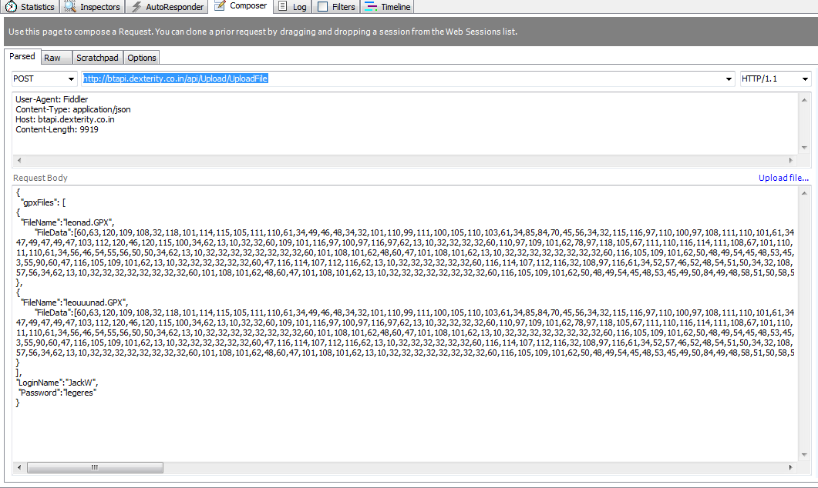

* Double click on result and you will be landed on below page, in which you can see the output of API:

